Congue nihil imperdiet doming id quod mazim placerat facer minim veni am ut wisi enim ad minimeniam, quis erat nostr uexe

rci tation ullamcorper nostru exerci tation ullam corper et iusto odio dig nissim qui blandit praesent lupta. Tummer delenit

augue duis dolore te feugait nulla facilisi. Con erattis sectetuer adip iscing elit, sed erat diam nonummy nibh magna erat.

The entire floor plate of 1,127 square metres is available that will be configured to meet the tenants requirement. The floor diagram overleaf shows various configurations, these are a guide only.

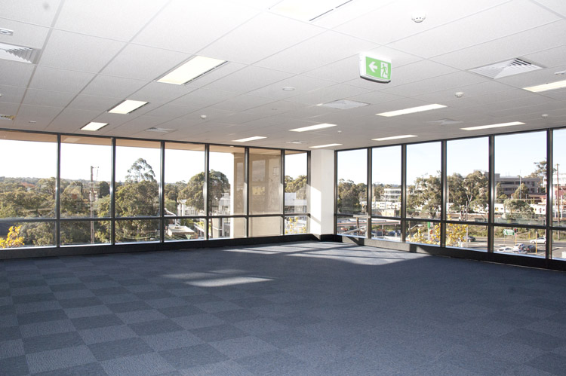

|  |  |
| --- | --- |
| Office | Floor area/sqm |
| Ground Floor 04 | 110 |
| Level 101 | 155 |
| Level 102 | 295 |
| Level 103 | 395 |
| Level 104 | 144 |
| Whole floor plate | 1,127 |
| Part floor plate | 500 |

Conveniently located 400 metres (approximately) from the Epping Metro Station which is now transport hub with connections to the North Shore(15mins to Chatswood) the Sydney CBD, Hornsby, the Northwest (8 mins to Castle Hill) central coast, and western suburbs including Parramatta.

Epping is also a major bus terminus with buses to Parramatta, and all northern suburbs.

The whole Sydney metropolitan area and CBD is conveniently accessible by road via the M2/M7 Westlink motorway.

**Office for Lease**

***Suites for lease***

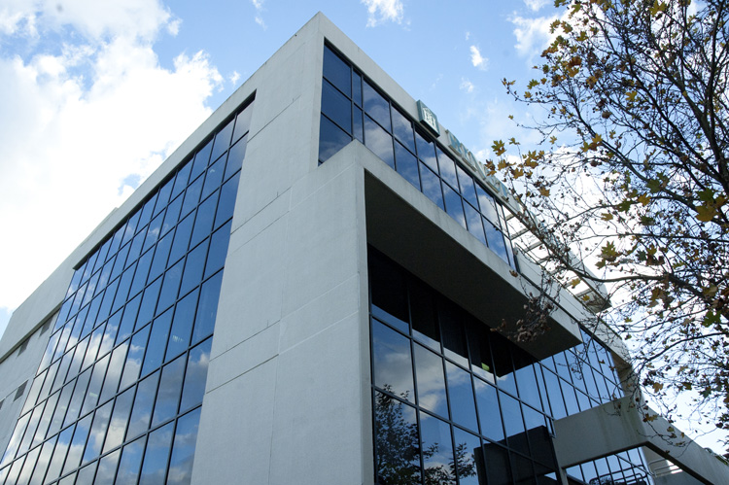

The Binet Building is a modern five level commercial office building situated on the corner of Rawson St & Carlingford Rd in Epping, 1 km from the M2 Motorway on and off ramp east to and from the Sydney CBD.

The office building is light and airy with floor to ceiling windows designed through offsets and balconies to maximise the feeling of open spaces within the building.

Onsite secure basement parking and short term parking in the the surrounding car park is available for staff and visitors.

PO Box 1951

Macquarie Park

NSW 2113

Contact Alan Barry

**0408 034 211**

[alan.barry@griffinproperty.com.au](mailto:alan.barry@griffinproperty.com.au)

View details at www.griffinproperty.com.au



Situated in the Epping precinct are a variety of cafés, restaurants, a conference centre, Gyms, the Epping Club and a local Pub as well as convenience shopping at the supermarket next door. Schools and childcare is available in the area.

*3 Carlingford Road*

*Epping*

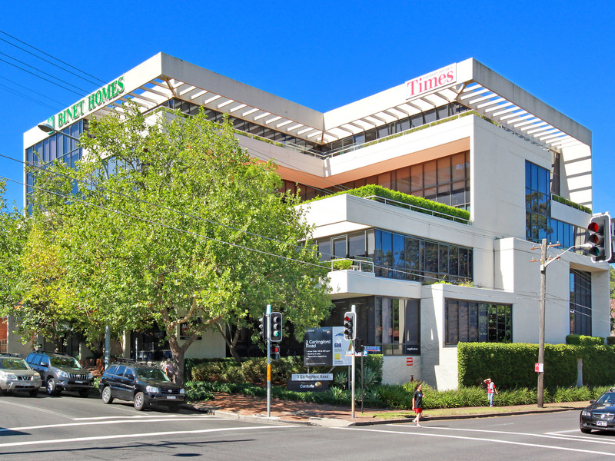

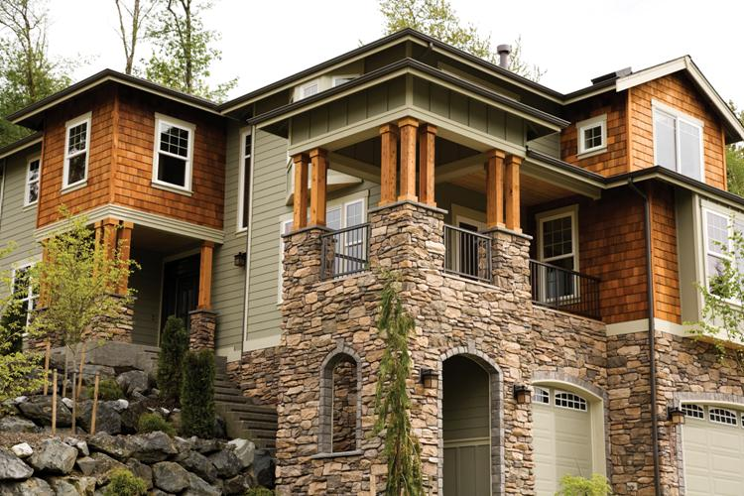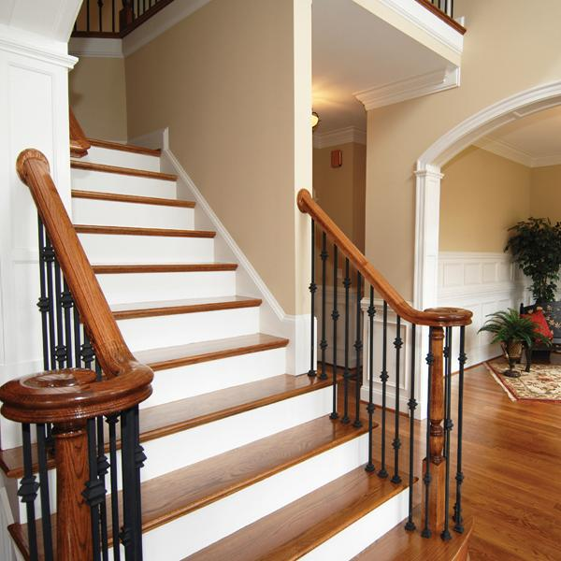

Tummer delenit   
augue duis dolore te feugait nulla facilisi con erattis secte

tuer adip iscing elit.

Option congue nihil imper diet doming id quod mazim placerat facer minim veni am utte wisi enim ad minimeniam, quis nostr uexerci tation ullamcorer.

corper et iusto odio dig nissim qui blandit praesent lupta tum delenit. Puod mazim placerat facer minim veni am ut wisi .

minimeniam, quis erat nostr uexerci. Quod mazim placerat facer mini veni am ut wisi enim ad minimena, quis erat nostr uexerci. Nostru ex

diam nonummy nibh ut wisi enim ad minim veni am, quis nostruexerci tation ull am corper. Nostru exe rcitation ull am corper et iusto odio

***Financing >>>***

Congue nihil imperdiet doming id quod mazim placerat facer minim veni am ut wisi enim ad

***Selling Property >>>***

Puod mazim placerat facer   
minim veni am ut wisi enim ad minimeniam, quis erat nostr uexe rci tation ullamcorper nostru   
exerci tation ullam corper et iusto odio dig nissim qui blandit prae  
sent lupta. Tummer delenit augue duis dolore te feugait nulla facil  
isi. Con erattis

***Homebuyers >>>***

Imperdiet doming id quod mazim placerat facer minim veni am ut wisi enim ad minimeniam, quis erat nostr uexerci tation ullamcorper nostru exerci tation ullam corper et iusto odio dig nissim qui blandit praesent lupta. Tummer delenit augue duis dolore te feugait nulla facilisi. Con erattis sectetuer adip iscing elit, sed erat diam nonummy nibh magna erat aliquam erat volutpat. Nam liber tempor cum soluta nobis sed diam nonummy nibh ut wisi enim ad minim veni am, quis nostruexerci tation congue

***Finding an agent that’s right for you >>>***

***We are with you every step of the way >>>***

***Friendly, Knowledgable Agents***

*Imperdiet doming id quod mazim placer*

*at facer minim veni am ut wisi enim ad minimeniam, quis erat nostr uexerci tation ullamcorper nostru exerci tation.*

*Imperdiet doming id quod mazim placerat facer minim veni am ut wisi enim ad minimeniam, quis erat nostr uexerci tation ullamcorper nostru exer ci tation ullam corper et iusto odio dig nissim qui blandit praesent lupta. Tummer delenit augue duis dolore te feugait nulla facilisi.*

Congue nihil imperdiet doming id quod mazim placerat facer minim veni am ut wisi enim ad minimeniam, quis erat nostru exer tation ullamcorper nostru exerci tation ullam corper et iusto odio dig nissim qui blandit praesent lupta. Tummer delenit augue duis dolore te feugait nulla facilisi. Con erattis sectetuer adip iscing elit, sed erat diam nonummy nibh magna erat aliquam erat volutpat. Nam liber tempor cum soluta nobis sed diam nonummy nibh ut wisi enim ad minim veni am, quis nostruexerci tation ullam corper. Option congue nihil imperdiet doming id quod mazim placerat facer minim veni am utte wisi enim ad minimeniam, quis nostr uexerci tation ullamcorer. Nostru exerci tation ullam corper et iusto odio dig nissim qui blandit praesent lupta tum delenit.

**Dependable** imperdiet doming id quod mazim placerat facer minim veni am ut wisi enim ad minimeniam, quis erat nostr uexe

rci tation ullamcorper nostru exerci tation ullam corper et iusto odio dig nissim qui blandit praesent lupta. Tummer delenit augue duis dolore te feugait nulla facilisi. Con erattis sectetuer adiping elit, sed erat diam nonummy nibh magna erat aliquam volutpat.

Nam liber tempor cum soluta nobis sed diam nonummy nibh ut wisi enim ad minim veni am, quis nostruexerci tation ullam corp-er. Option congue nihil imperdiet doming id quod mazim placerat facer minim veni am utte wisi enim ad minimeniam, quis nostr uexerci tation ullamcorer.

*Looking for a Place to Call Home*

Imperdiet doming id quod mazim placerat facer minim veni am ut wisi enim ad minimeniam, quis erat nostr uexerci tation ullam corper nostru exerci tation ullam corper et iusto odio dig nissim qui blandit praesent lupta. Tummer delenit augue duis dolore te feud iam nonummy nibh magna erat aliquam erat volutpat.

nihil imperdiet doming id quod mazim placerat facer minim veni am, quis nostr ue ullamcorer. Nos tru exerci tation ullam corper et iusto odio dig nissim qui blandit praesent delenit.

sectetuer adip iscing elit, sed erat diam nonummy nibh magna erat aliquam erat volutpat. Nam libe r tempor cum soluta nobis sed